* 1. Getting Started

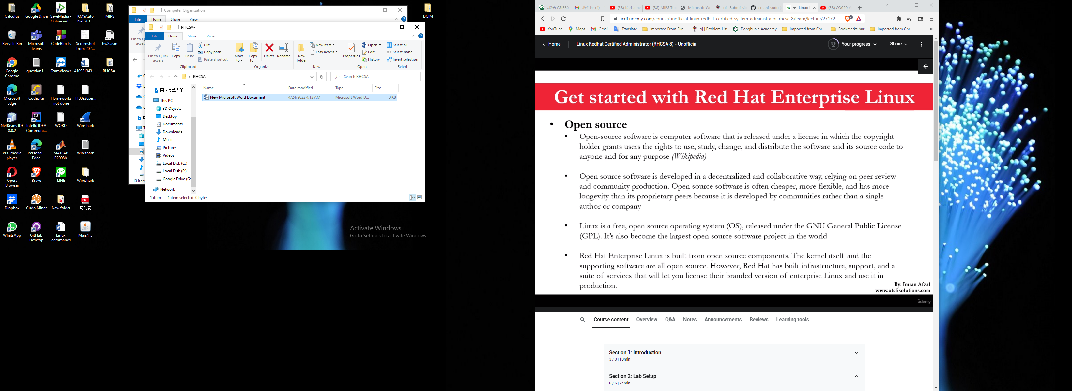

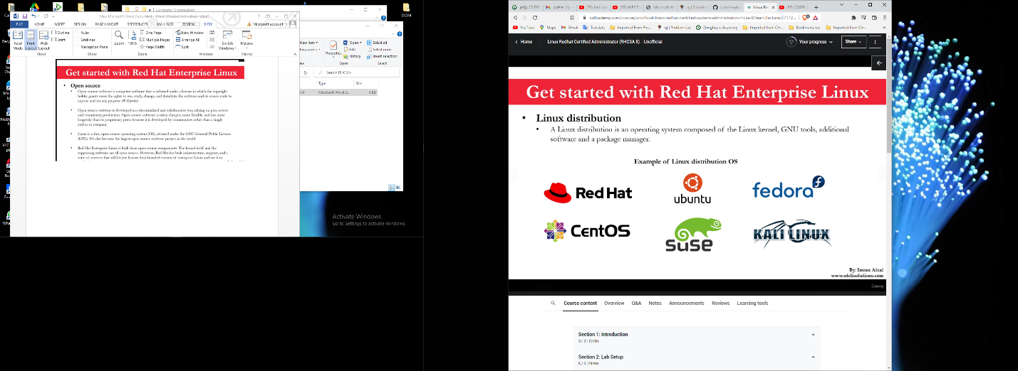

**12. Accessing the command line**

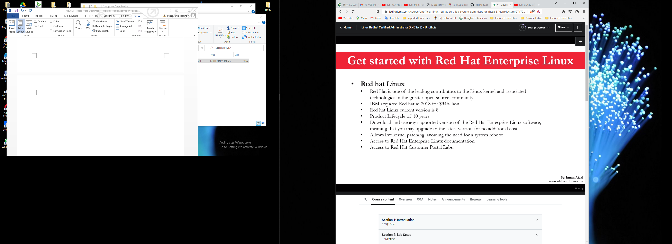

Linux System Access (Command Line and GUI)

**12. Access the command**

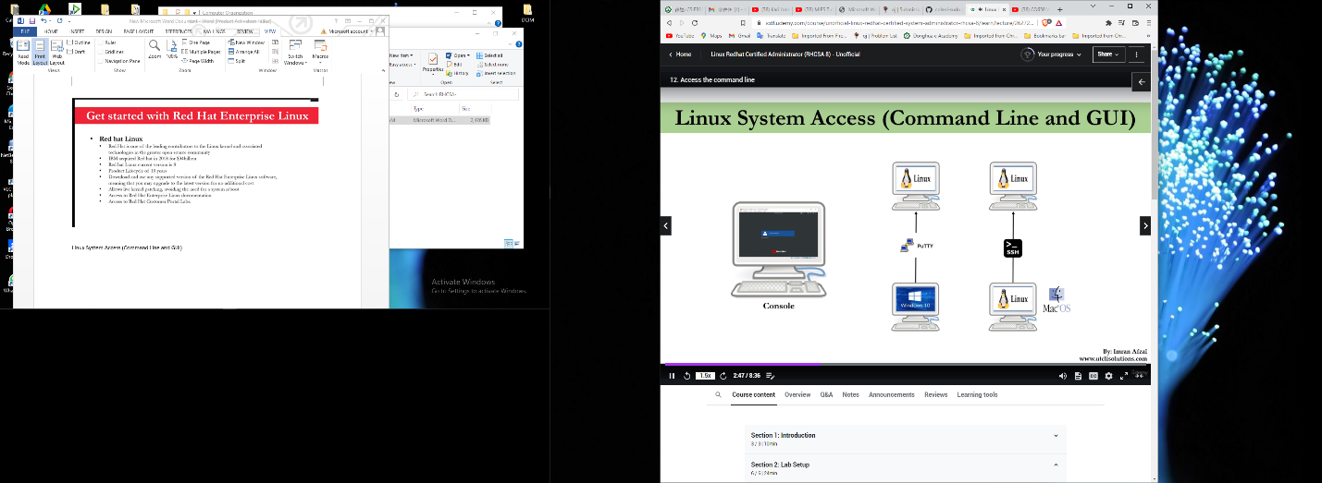

**Accessing a Linux System using Putty**

First get the ip address of the Linux server you want to access

**Accessing a Linux System from another Linux system using SSH**

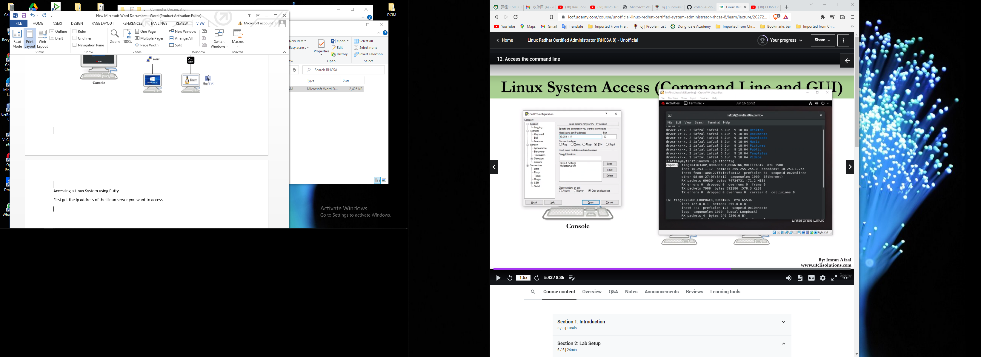

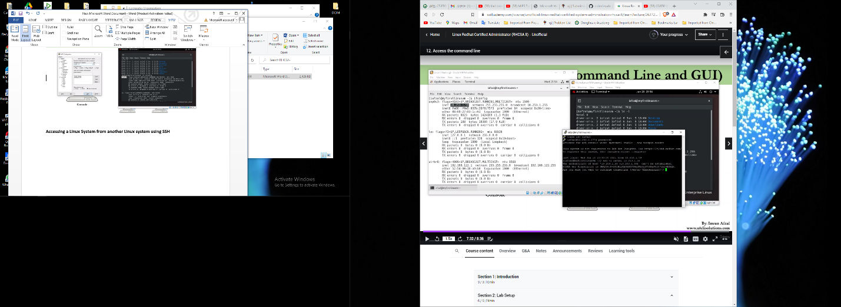

**13. Manage files from the command line**

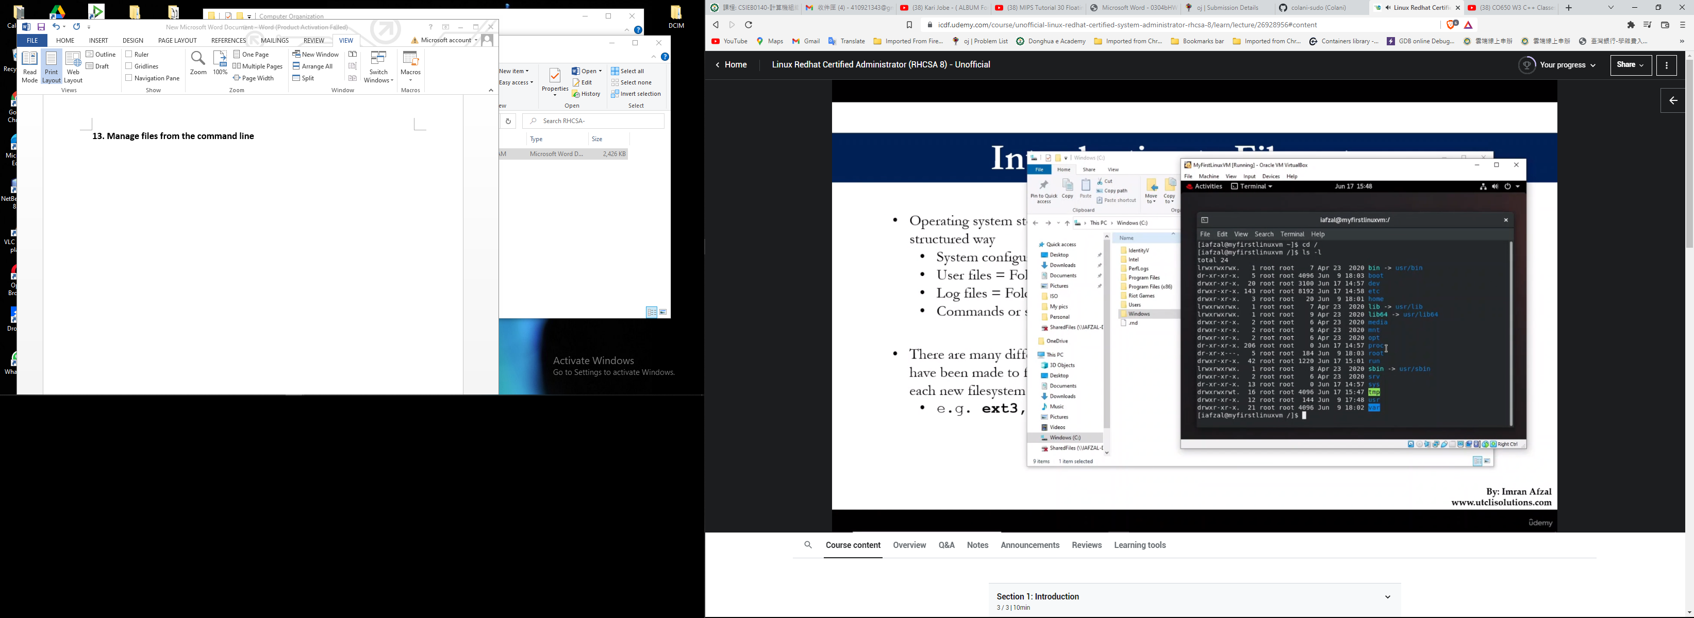

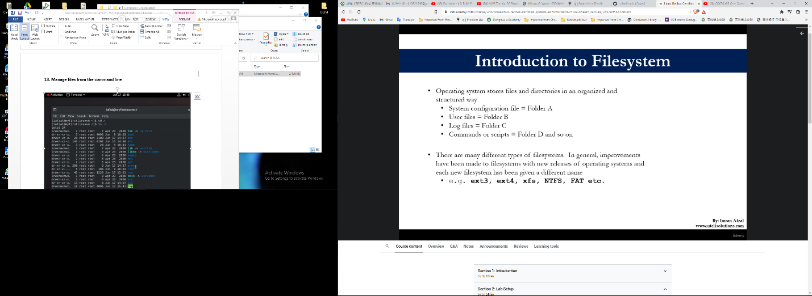

**ls -l attributes**

d - for directories

l - for links

- - for any files

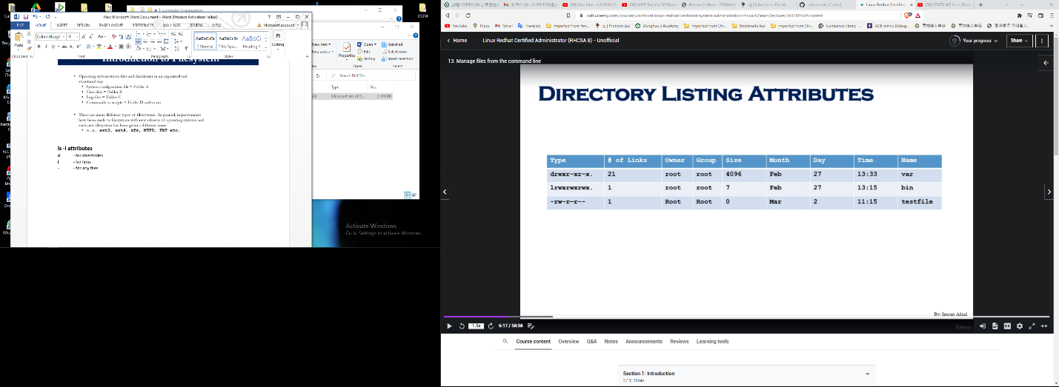

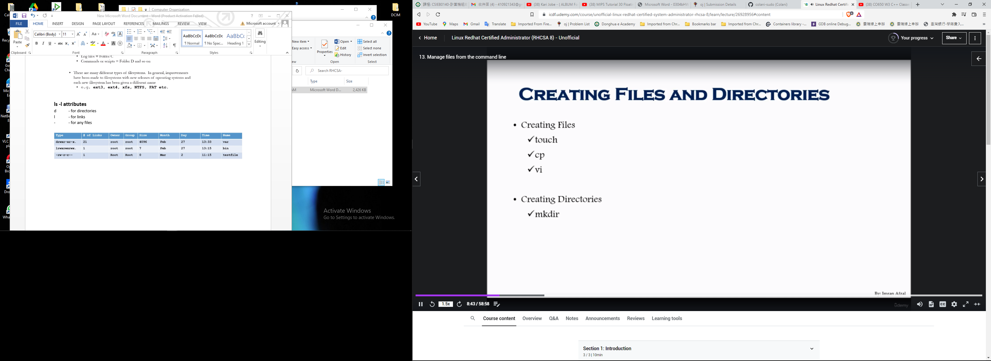

**whoamI #know which user you are logged in as**

**pwd**

**touch file1 #create a file**

**ls – l #verify if file was created, list files**

**ls –ltr #list files according to date created**

**cp file1 file2**

**vi file3 #opens/create a vim file in command mode, type :wq! To save and quit**

**mkdir folder1**

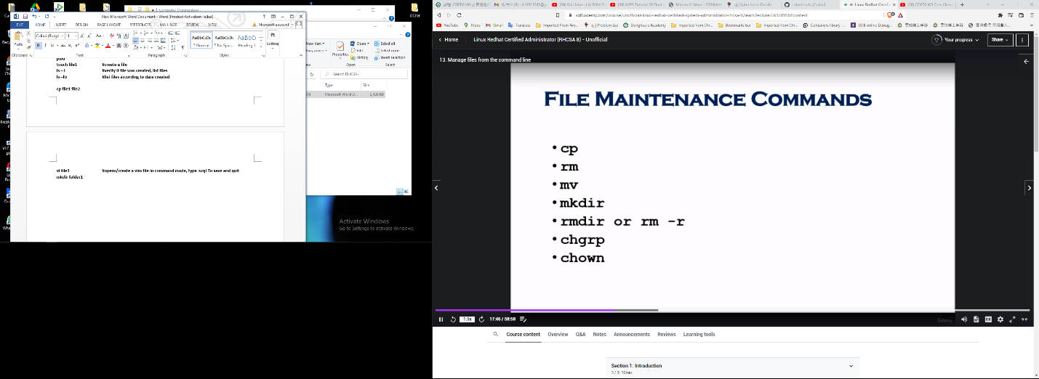

**cp file1 david**

**echo “david puddy is Eliane’s boy friend” > david**

**cat david**

**cp david /tmp //copy david file to the temp directory**

**rm file1**

**mv david luther //rename david file to luther**

**mv luther /tmp/vandross //copied luther to tmp and renamed it as vandross**

**rm –r luther //delete file luther**

**chgrp root puddy //cannot, you must be root**

**su – root //switch user to root**

**chgrp root puddy //now can change the group or puddy to root as we have all permissions**

**chown root puddy //change ownership of puddy**

**chown king:king puddy //change group and ownership to king**

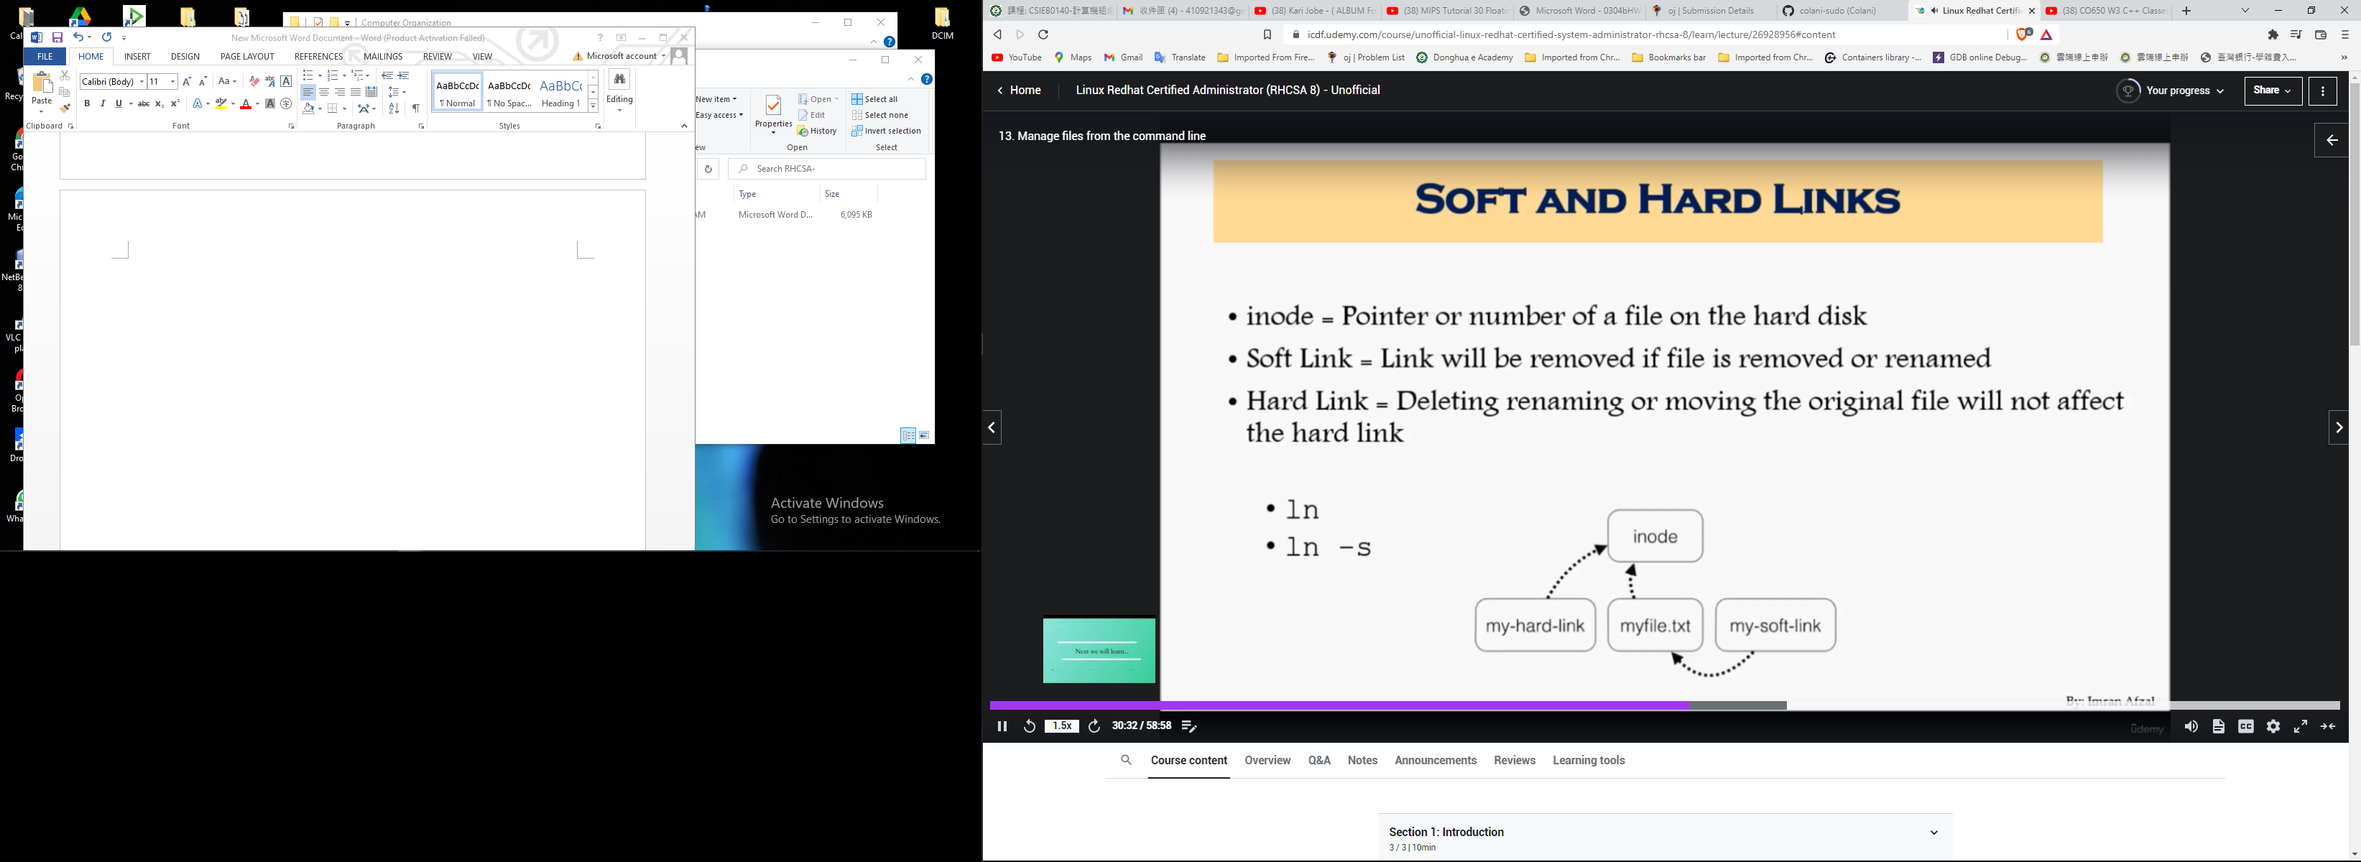

//assuming we are in the /home/king directory

**touch hulk**

**//to create a Soft Link to the hulk file**

**cd /tmp**

**ln –s /home/king/hulk //creates a softlink to hulk file in user king folder**

**ls –ltr //a link has been created with permissions lrwxrwxrwx**

**cd ../home/king**

**echo “hulk is a superhero” > hulk //adding data to the file here also updates the link file in temp**

**//back to home directory**

**ls -li //to list the inodes in this directory**

**ls -ltri //list the files with inodes at the end of the list**

**rm hulk //to remove a soft link**

**//To create a Hard Link**

**Touch hulk**

**Echo “hulk is a superhero” > hulk**

**cd /tmp**

**ln /home/king/hulk**

**ls –ltr //with a hard link there is no pointing to another file**

**//removing the source of the file does not remove the destination**

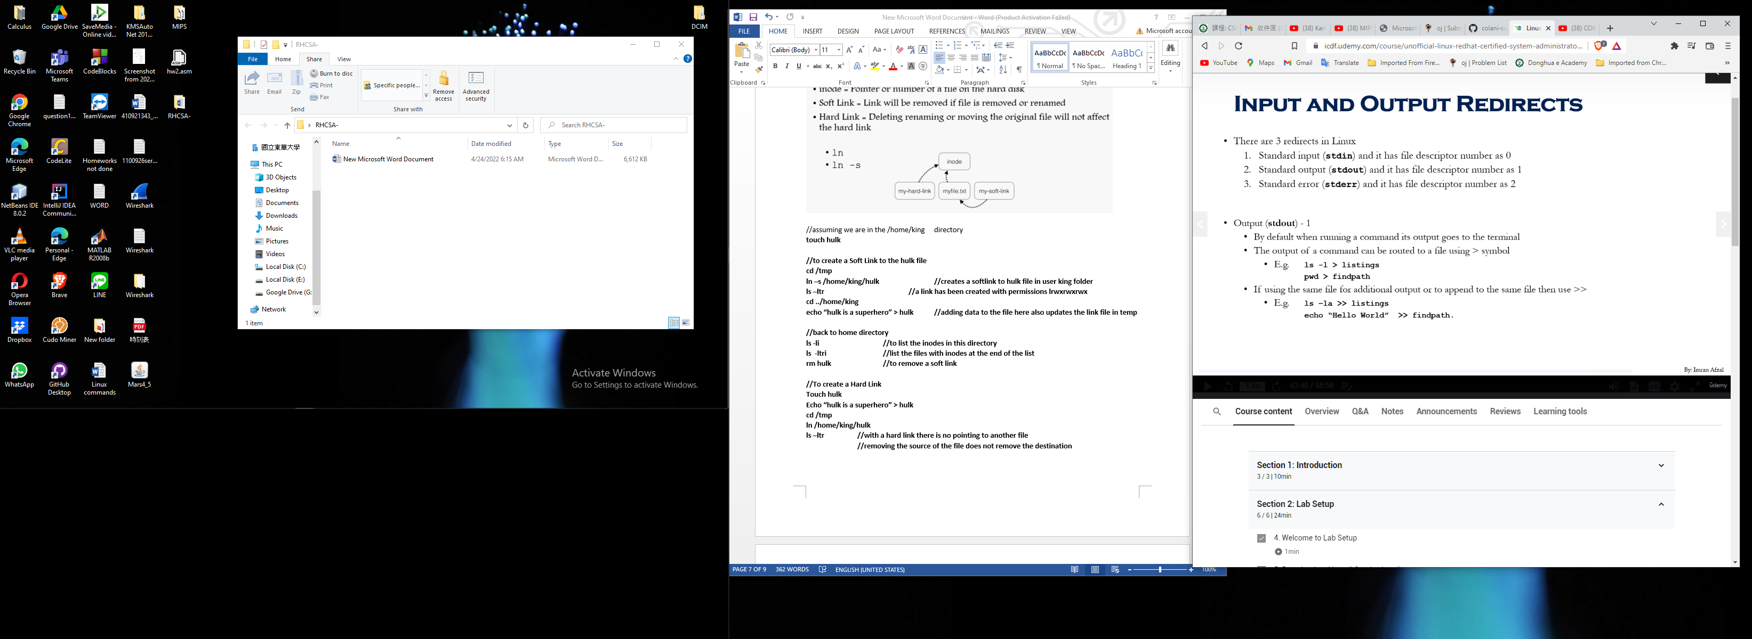

ls -l > listings //redirect output to a filename listings

pwd > filepath //redirect output to a filename filepath

ls -la >> listings //to append the previous data with new one

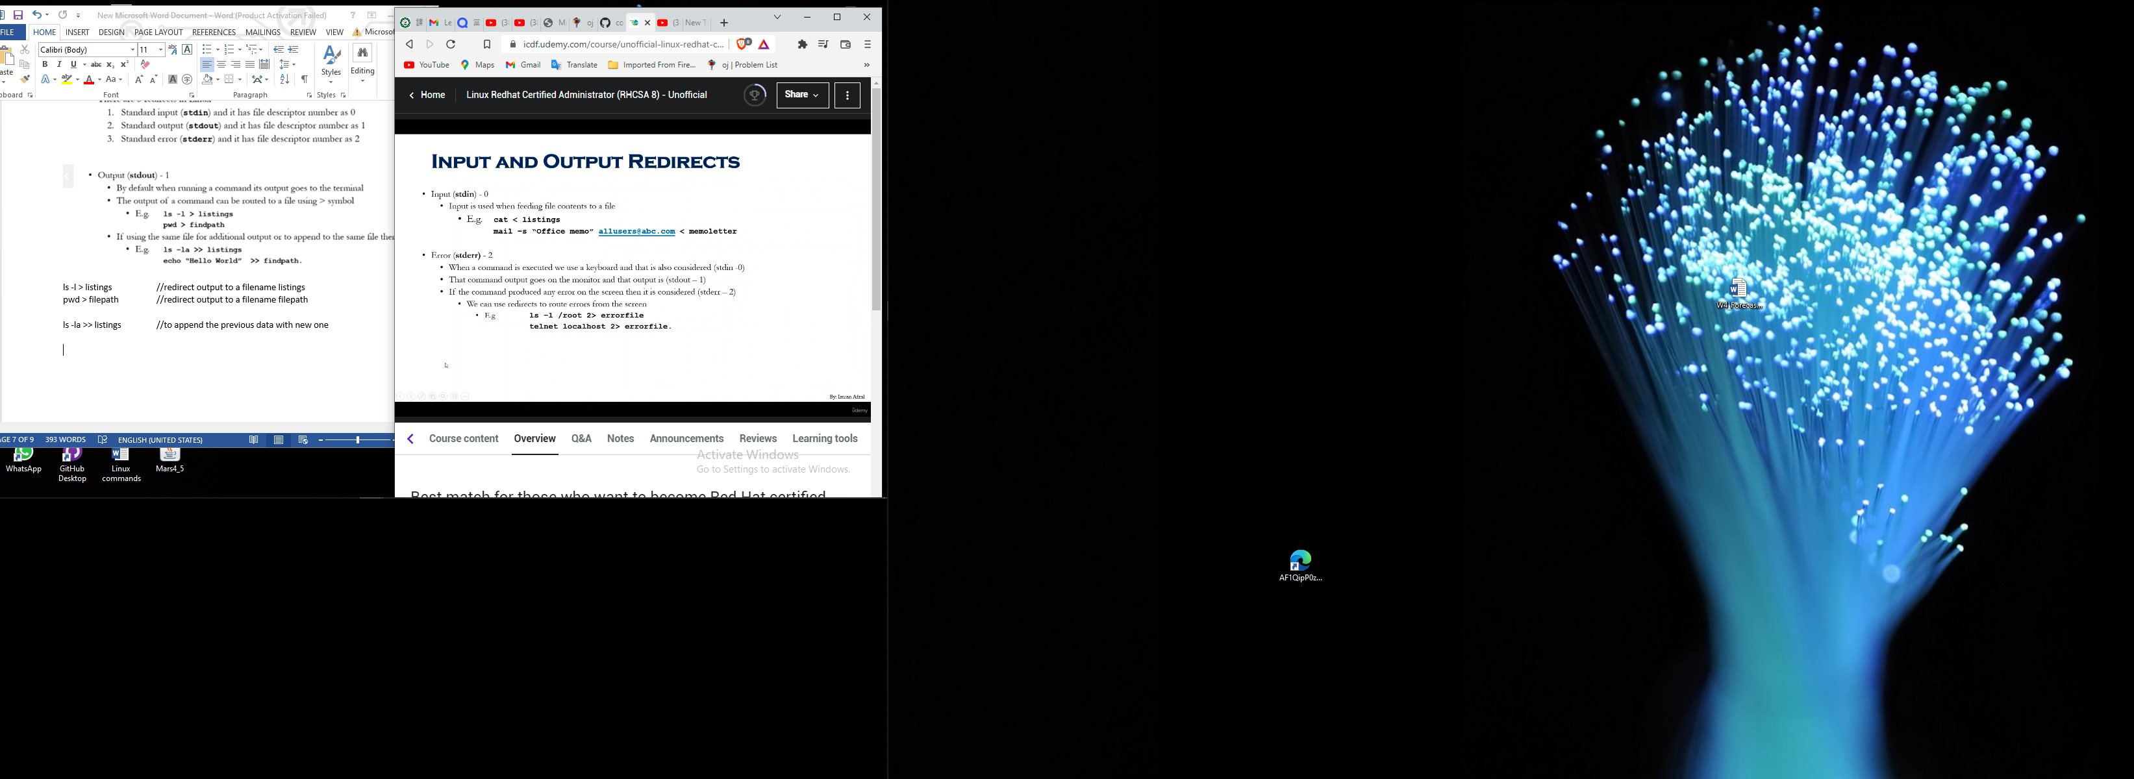

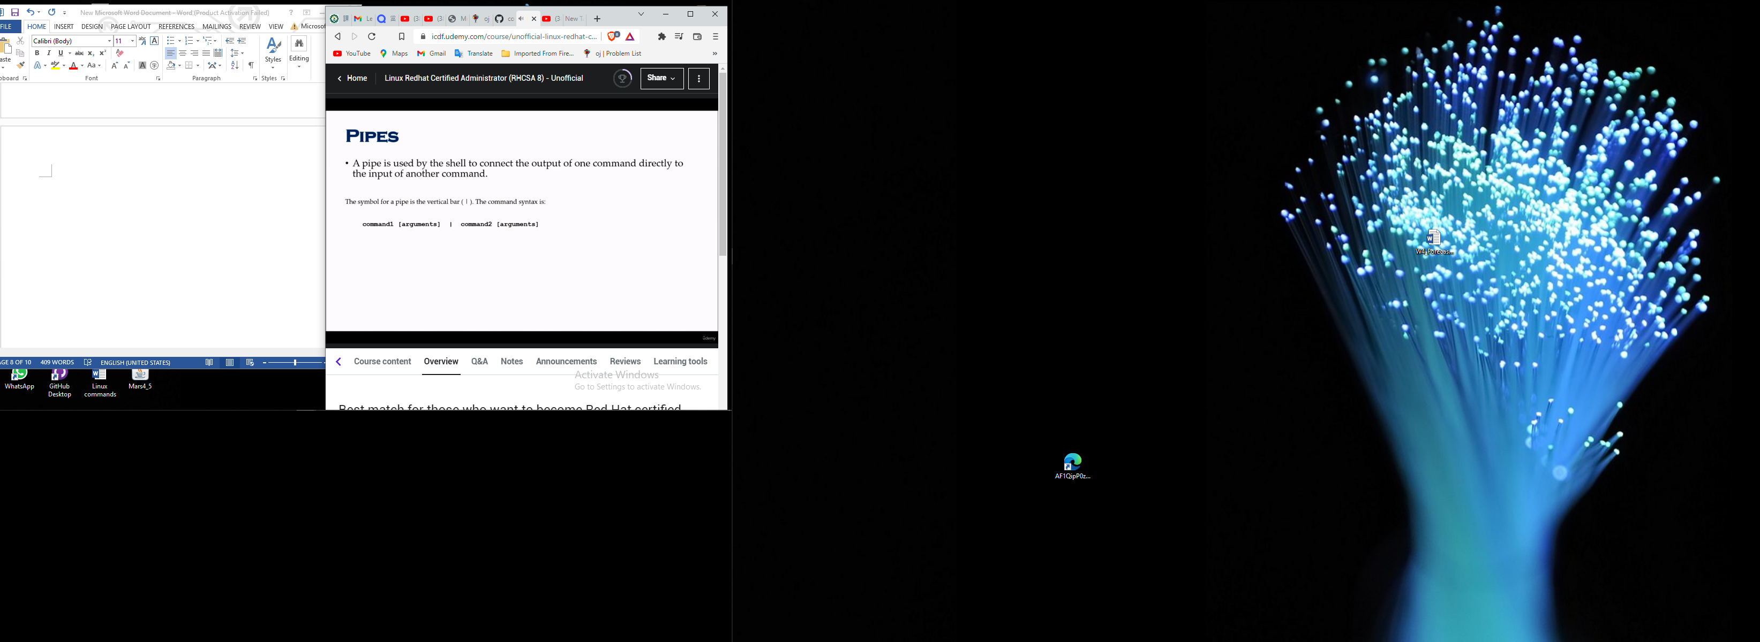

**Pipes are used to refine the output of a command**

**ls –ltr | more //gives you the output of a page one more at a time**

**ls -l |tail -1 //shows the last file/item in that pwd**